**Lexar® Professional GOLD microSDXC™ UHS-II Card**

256GB

128GB

[Where to buy](https://americas.lexar.com/product/lexar-professional-gold-microsdxc-uhs-ii-card/)

**Key Features:**

**Up to 280MB/s read, 180MB/s write speeds**

* High-Speed Performance
* Fast Video Capture
* With V60 Class
* Feature A1 Class

**Key Features:**

**Up to 280MB/s read, 180MB/s write speeds**

* High-Speed Performance
* Fast Video Capture
* With V60 Class
* Feature A1 Class

**Key Features:**

**Up to 280MB/s read, 180MB/s write speeds**

* High-Speed Performance
* Fast Video Capture
* With V60 Class
* Feature A1 Class

[Features](https://americas.lexar.com/product/lexar-professional-gold-microsdxc-uhs-ii-card/#feature-section)[Specifications](https://americas.lexar.com/product/lexar-professional-gold-microsdxc-uhs-ii-card/#specifications)[Part Numbers](https://americas.lexar.com/product/lexar-professional-gold-microsdxc-uhs-ii-card/#product-numbers)[Related products](https://americas.lexar.com/product/lexar-professional-gold-microsdxc-uhs-ii-card/#related-products)

**Features**

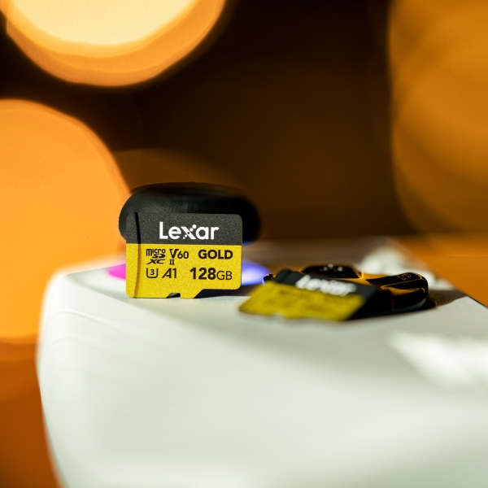

**Pro-level performance in a microSD card**

The Lexar® Professional GOLD microSDXC™ UHS-II Card is the perfect high-performance card for capturing drone and action camera footage and is also great for UHS-II portable gaming devices. Read speeds up to 280MB/s1allow you to quickly transfer massive amounts of files and load games fast while write speeds up to 180MB/s1 and a V60 rating let you capture high-quality images and extended lengths of Full-HD and 4K UHD video.

**Powerful Performance for Your Devices**

The Lexar® Professional GOLD microSDXC™ UHS-II Card is ideal for drone and action camera users that need to capture and quickly transfer massive quantities of files.

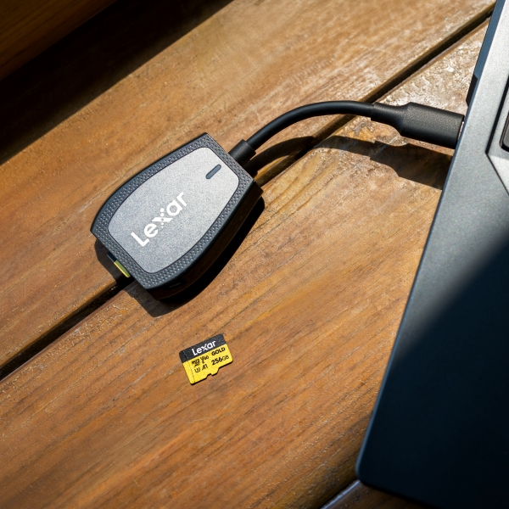

**Built for Speed**

Blazing-fast read speeds up to 280MB/s let you expedite your workflow and transfer files in a flash—up to 75% faster than with a UHS-I card.2 Pair with a UHS-II reader for maximum performance.

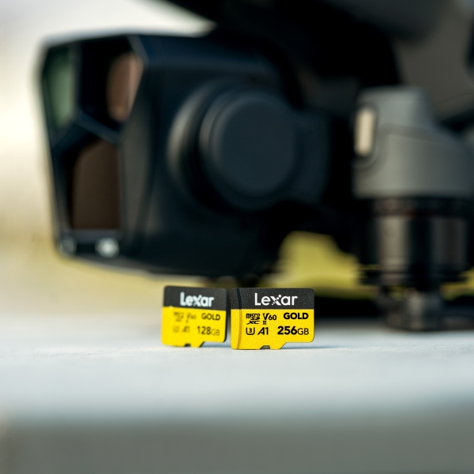

**Picture-worthy Performance**

With write speeds up to 180MB/s1 and a V60 rating, the Lexar® Professional GOLD microSDXC™ UHS-II Card is perfect for capturing high-quality images and Full-HD and 4K UHD video without dropping frames.

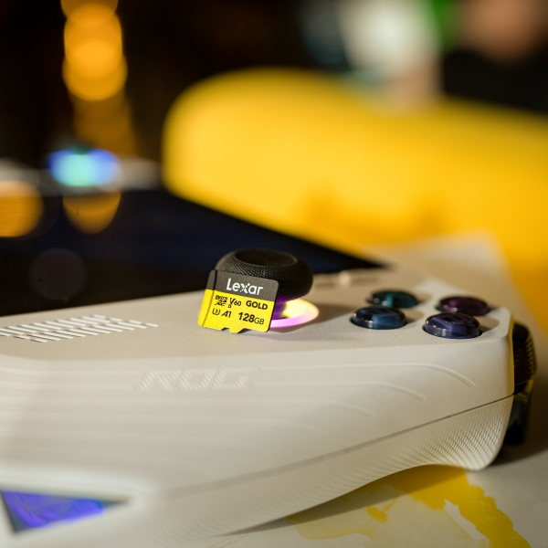

**Make the Most of Your UHS-II Portable Gaming Devices**

The Lexar® Professional GOLD microSDXC™ UHS-II Card lets you take advantage of your device’s UHS-II performance.

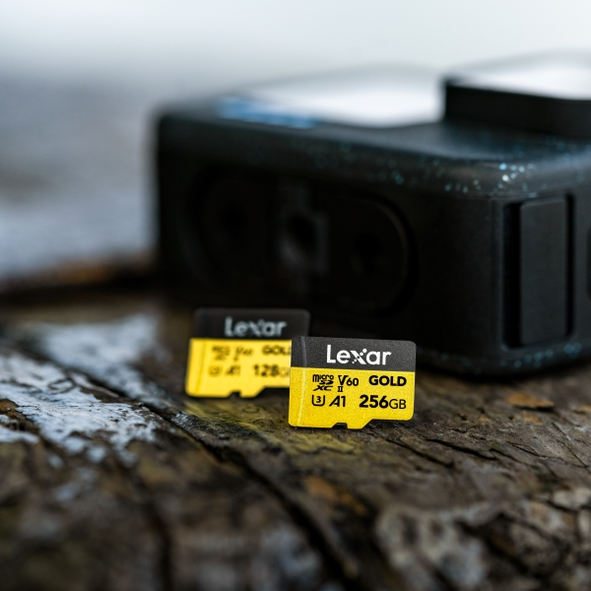

**10-year Limited Warranty**

Enjoy peace of mind knowing that your purchase is backed by one of the most robust warranties in the industry.

**Rigorously Tested**

All Lexar products undergo extensive testing in the Lexar Quality Labs, facilities with thousands of different cameras and digital devices to ensure performance, quality, compatibility, and reliability.

**Specifications**

* Capacity

256GB | 128GB

* Performance

Up to 280MB/s read, 180MB/s write speeds1

* Operating Temperature

-25°C to 85°C (-13°F to 185°F)

* Storage Temperature

-40°C to 85°C (-40°F to 185°F)

* Dimensions (L x W x H)

11mm x 15mm x 1mm / 0.43” x 0.59” x 0.04”

* Warranty

10 year limited warranty